Task 2.

Goals:

* Get data generator

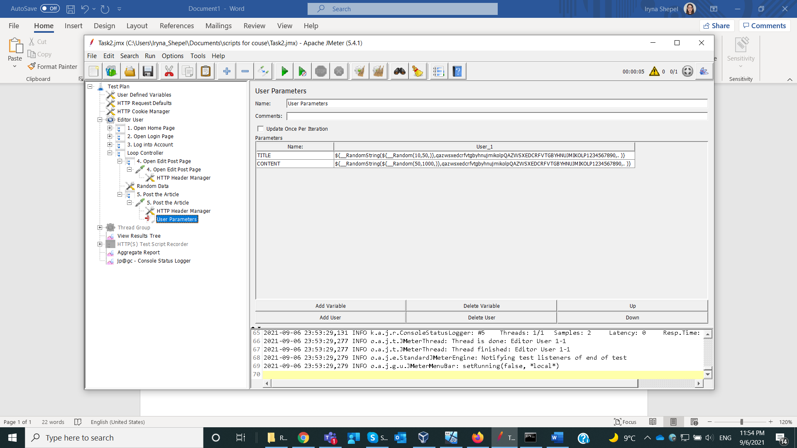

* Script login procedure

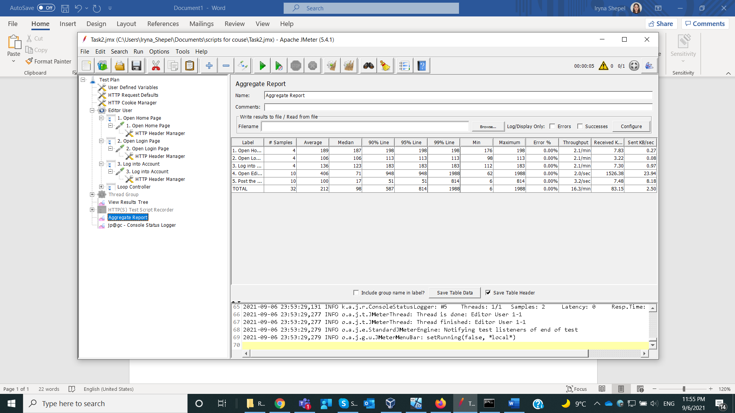

* Get experience of test data preparation

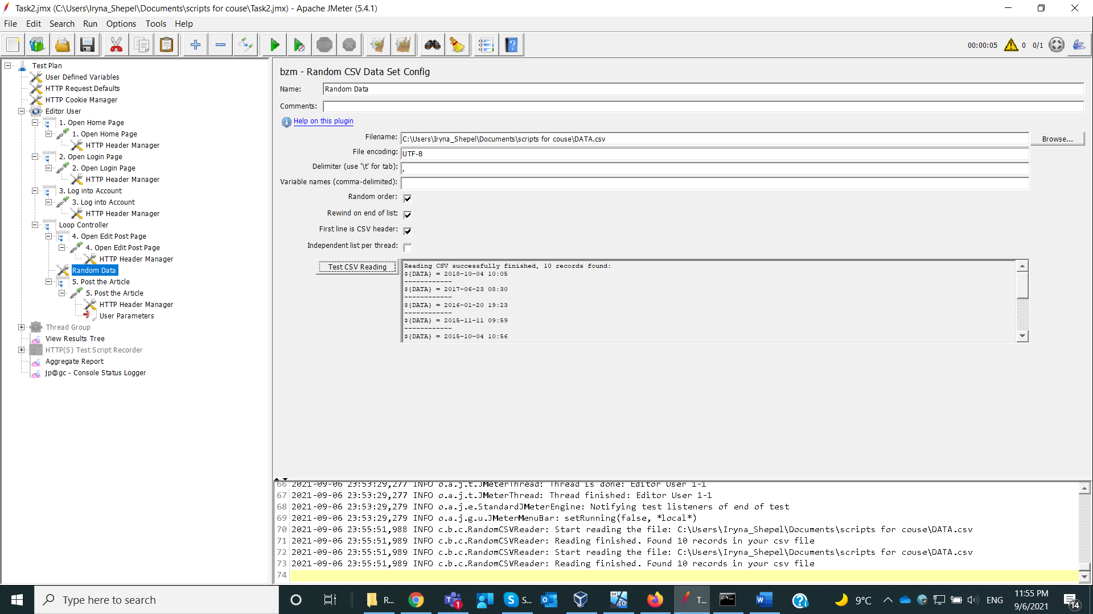

* Get estimated time needed for data generation

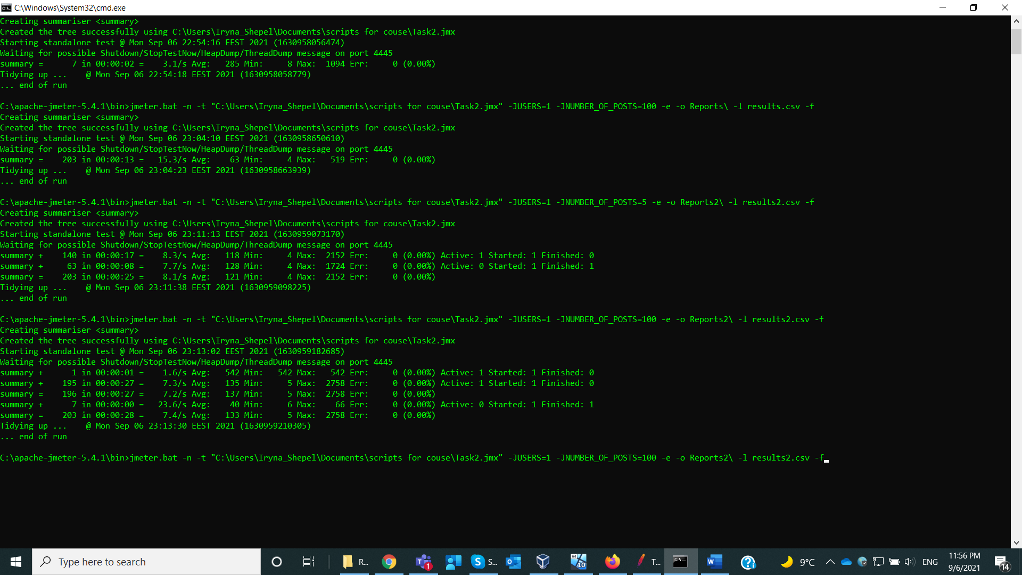

Need 27 sec to generate 100 posts